**Wednesday (8 -10) #2**

|  |  |  |
| --- | --- | --- |
| Student Name | ID | Tasks |
| Amani Nasser Alqhatani | 439201542 | Home, Join Club |
| Rowa Zuhair Alhassnan | 439201103 | Skin, Hair, Post |
| Nouf Bader Alshamik | 439201088 | About us, Contact us, Sitemap |
| Amal Rushood AlKharaif | 439201281 | Makeup, Gallery, Customize |

https://www.DaisyGarden.com

I. Ahlam & I. Ghaida Alfayez | IT312 Daisy Garden–Project Pahse#2 | 2020

**Site Map:**

Our Sitemap Online😊

[**https://www.gloomaps.com/ghMlwleYaf**](https://www.gloomaps.com/ghMlwleYaf)

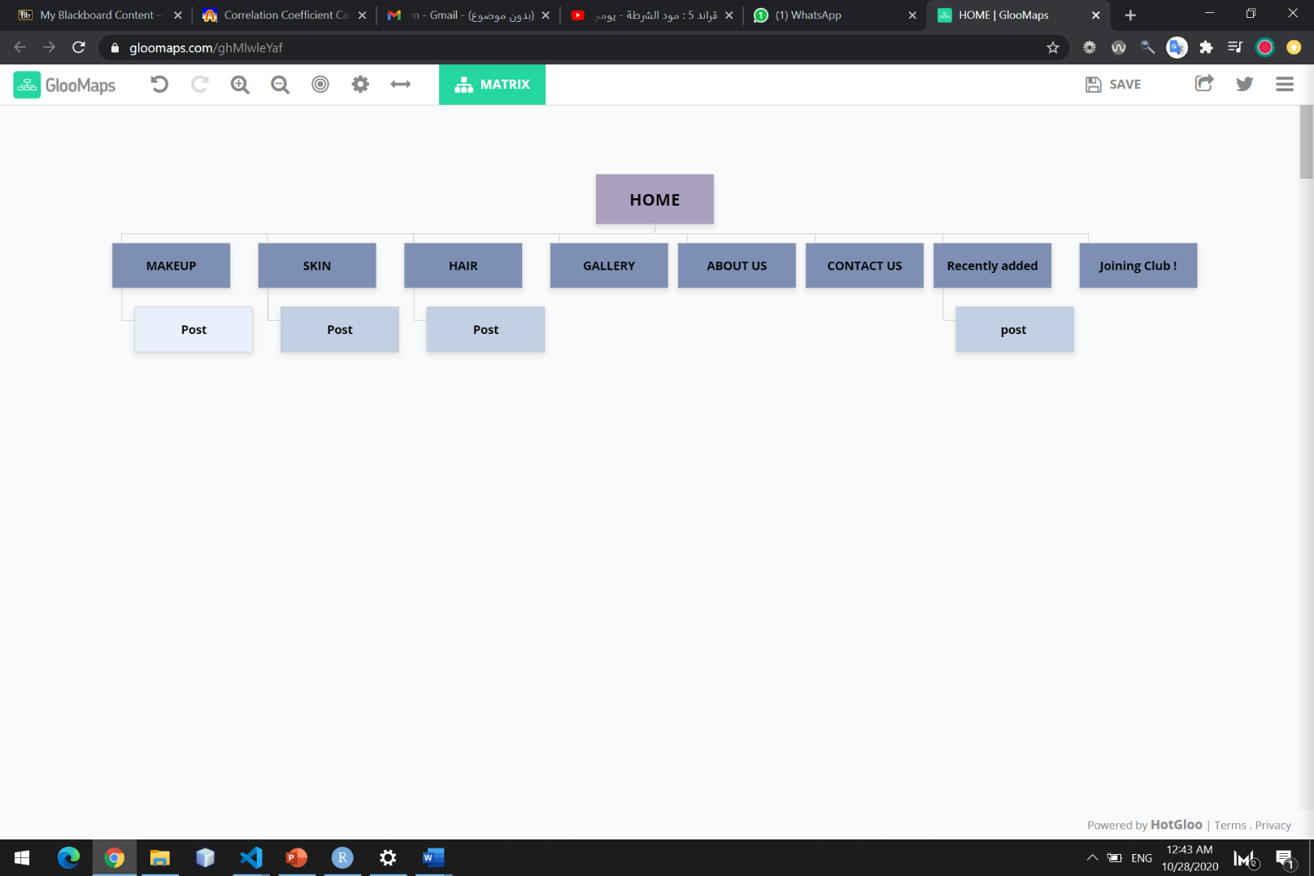

**Pages Layout:**

Page1: Homepage

|  |
| --- |
| Print Screen |
|  |
| Wireframe |
|  |

Page2: Joining Club

|  |
| --- |
| Print Screen |
|  |
| Wireframe |
|  |

Page3: Customize

|  |
| --- |
| Print Screen |
|  |
| Wireframe |
|  |

Page4: Skin

|  |
| --- |
| Print Screen |
|  |
| Wireframe |
|  |

Page5: Hair

|  |
| --- |
| Print Screen |
|  |
| Wireframe |
|  |

Page6: Makeup

|  |
| --- |
| Print Screen |
|  |
| Wireframe |
|  |

Page7: Gallery

|  |
| --- |
| Print Screen |
|  |
| Wireframe |
|  |

Page8: About us

|  |
| --- |
| Print Screen |
|  |
| Wireframe |
|  |

Page9: Contact us

|  |
| --- |
| Print Screen |
|  |
| Wireframe |
|  |

Page10: SiteMap

|  |
| --- |
| Print Screen |
|  |
| Wireframe |
|  |

Page11: Post

|  |
| --- |
| Print Screen |
|  |
| Wireframe |
|  |

**Creativity:**

Creativity 1: Favorite Icon

Creativity 2: Floating label

Creativity 3: Required field

Creativity 4: Popup windows (Join club, customize)